**SOFTWARE REQUIREMENTS SPECIFICATION DOCUMENTATION FOR TRAVEL WEBSITE**

**INTRODUCTION**

**ABSTRACT**

In today's era of travel, exploring India's diverse landscapes and cultures is a popular choice among adventurers and wanderers. Travel in India aims to cater to this enthusiasm by offering a user-friendly website that facilitates seamless travel experiences for visitors. The platform addresses various traveler needs, including destination recommendations based on interests, itinerary planning, accommodation bookings, transportation options, easy navigation through India's vast geography, payment facilities, real-time travel updates, communication with local guides, as well as streamlined booking modifications and cancellations. Furthermore, an administrator login enables essential tasks such as updating destination information, managing bookings, and monitoring traveler feedback to ensure a memorable journey for all.

**SYSTEM REQUIREMENTS**

**FUNCTIONAL REQUIREMENT**

The Functional Requirement Specification describes what tasks and activities a system can do. It is created to be understandable by the Customers.

* New User Registration
* Login with credentials
* Home Page contains all States in India
* Browse all States in India
* Search a particular State
* Plan a trip to particular States
* Read More on a Particular state
* Continue to the official site of State Tourism
* Accommodation, transportation, and travel updates
* Online Payments and real-time traveler updates

**NON-FUNCTIONAL REQUIREMENT**

The Non-functional Requirement Specification explains how well the system should perform and any limitations it must meet. what it can do. It's written so that anyone can understand it easily.

* Performance
* Scalability
* Security
* Availability
* Cross-platform Support

**MODULAR DESCRIPTION**

1. To Create a new User, users need to provide their email, username, and password. The Email and Username must be unique and should not be used by anyone. Password must be strong with at least 8 characters long to ensure site security and speed.
2. The state catalog module organizes and displays various states for travel. It helps users find what they need by searching states. It manages state listings, in alphabetical order, and search functions efficiently.
3. Once logged in, users can see state details like state images, brief about the states, plan a trip option, and read more about the state button.
4. After Viewing the site the user can log in with their Login credentials. If the user is new to the site then the user must create a new user account. After the user login can select a state, By clicking plan a trip user can be redirected to the official site of the state.
5. Only registered users can plan a trip to states; others cannot.
6. Admins can log in and access the entire database and user accounts with maximum privileges.

**SYSTEM ARCHITECTURE**

**FLOW CHART**

User visits website

NoN

Login with registered credentials

User registers an account

Is user new?

Yes

**User search the states**

User browses States

User clicks Plan a trip Button

User select a particular State

Official Site of the particular State Opens

Yes

**USE CASE DIAGRAM**

This use case diagram illustrates the connections between customers and administrators.

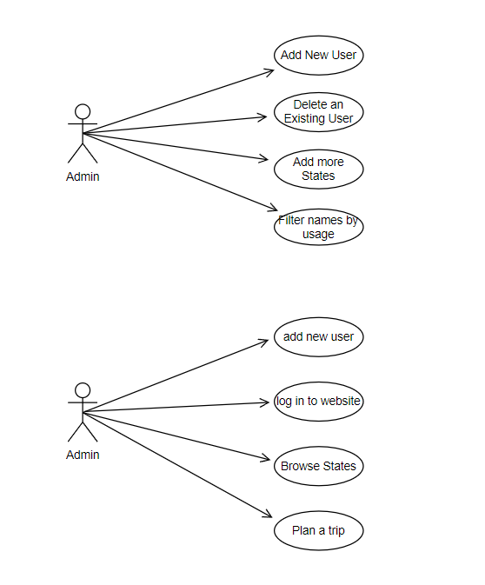

**CLASS DIAGRAM**

In this class diagram, the relationships between buyers and administrators are depicted.

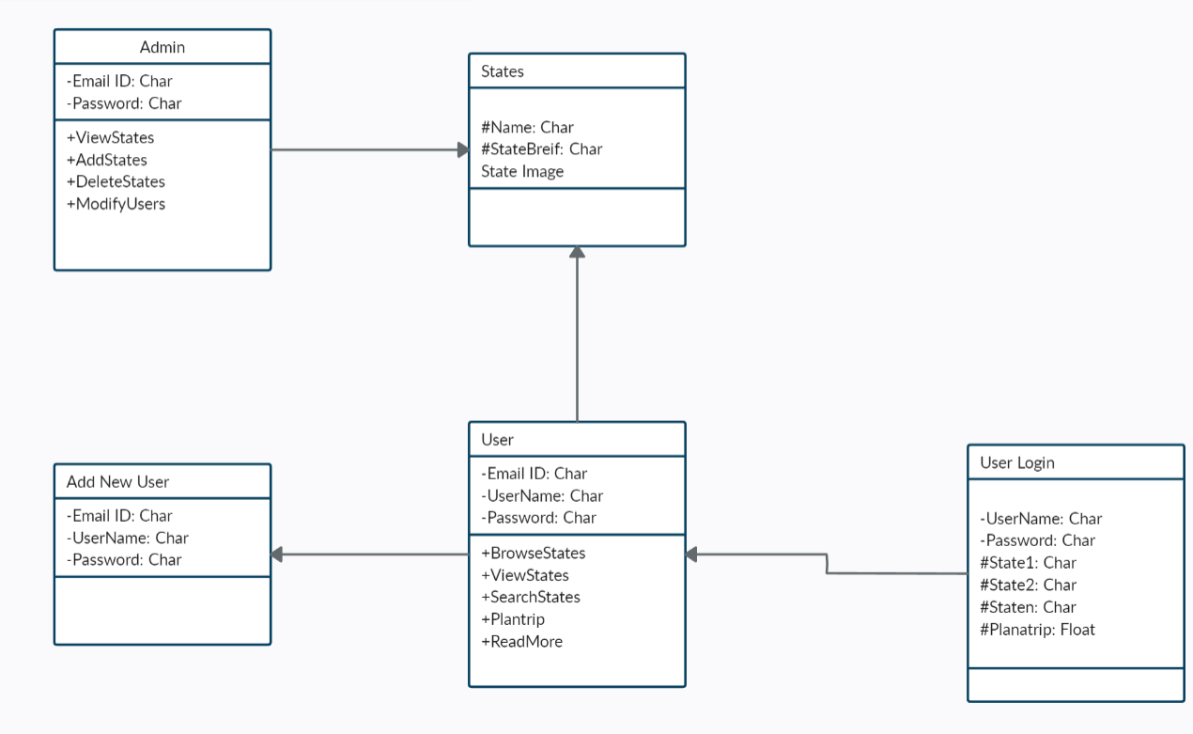

**SEQUENCE DIAGRAM**

In this sequence diagram, the interactions between buyers and administrators are illustrated.

